 [Translated from German to English - www.onlinedoctranslator.com](https://www.onlinedoctranslator.com/en/?utm_source=onlinedoctranslator&utm_medium=docx&utm_campaign=attribution)

**1 Mechanics**

Hydraulic press Hero Technical Documentation

0 by Dr.-Ing. Paul Christlani GmbH & Co.KG **5**

**1.1 Functional description**

In the hydraulic press, workpieces can be machined with a force of 600 N (at approx. 7 bar).

After the workpieces are inserted, the workpiece holder transports the parts to be processed into the press chamber. The safety door then closes and the press cylinder begins to extend. After processing, the safety door opens and the workpieces are pushed out of the work chamber, ready for further transport.

The safety door ensures that the press has a completely enclosed working area during the pressing process, but the Plexiglas safety walls allow for observation of the pressing process. To further increase safety, a two-hand control is used for manual operation.

The functional assembly is mounted on 2 profile plates and can be installed together with other assemblies on an aluminum grooved plate.

Two 8-bit transfer connectors are available as transfer modules for connection to six digital PLC inputs and eight digital PLC outputs.

The supply voltage of the functional module is 24 VDC and is established via the 10-pin connecting cable

The air supply is via 4 mm air connection, the operating pressure**is**4 bar.

**Safety notice:**

**for**The hydraulic system is supplied with pressure-tested components. Before commissioning the press, the hydraulic circuit must be**1**minute with 3❑ bar.

Whenever changes are made to the hydraulic system, only tested components may be used and the pressure test must be repeated.

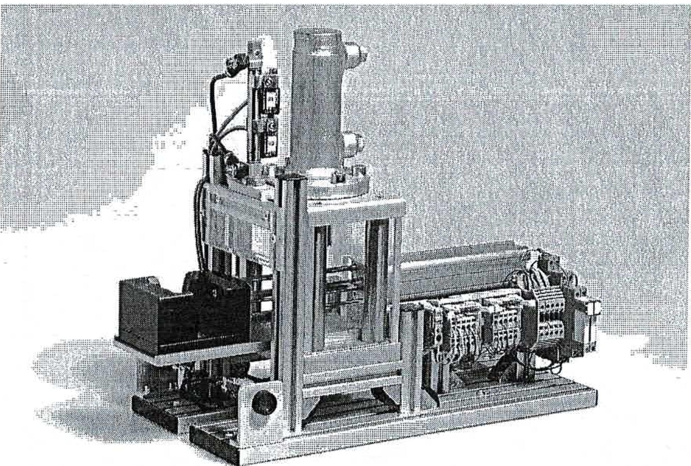

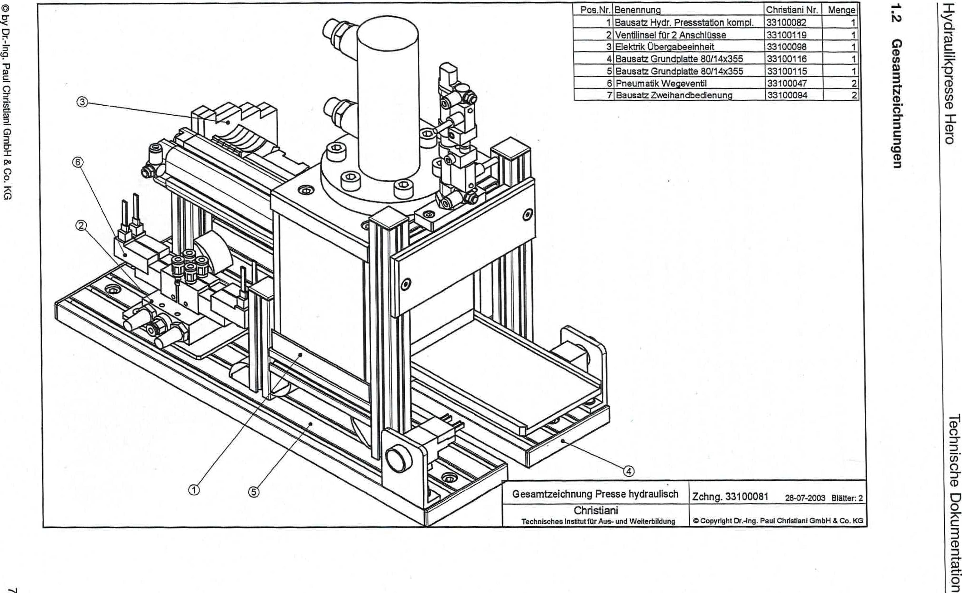

by Dr.-Ing. Paul Christiani GmbH & Co. KG

**ueßunutiopnwesao**

ataH essoidmilnaipÄH

uonewawmpa egosppoi

|  |  |  |  |
| --- | --- | --- | --- |
| Item No.. | designation | Christian' No. | Crowd  1 |
| 1 | Hydraulic pressing station kit complete. | 33100082 |
| 2 | Valve island for 2 connections | 33100119 | 1 |
| 3 | Electrical transfer unit | 33100098 | 1 |
| 4 | Base plate kit 80114x355 | 33100116 | 1 |
| 5 | Bausae base plate 80114x355 | 33100115 | 1 |
| 6 | Pneumatic directional valve | 33100047 | 2 |
| 7 | Two-hand operation kit | 33100094 | 2 |

General drawing of hydraulic press

Drawing 33100081 28-07-2003 Pages: 2

Christiani

Technical Institute for Education and Training

Copyright Cf.-Ing. Paul Christianl GmbH & Co. KG